◆ Platform User Guide — Complex Manager ◆
For: the complex manager, who follows every school in their complex
Your scope is a whole complex, not a single school. And you are part of the “supporting team”: you observe the lessons whose subject has no supervisor — roughly five lessons in every twenty-five, which would otherwise go unrated.
Before you start — four things that concern everyone
1. Open the link — https://ahseyam.github.io/unified-lesson/
2. Switch to English — the EN button, top right
3. Choose your role — one card per role
4. Enter your staff number — you are identified by it, not by your name

• Open the link: It runs on phone, laptop and tablet with nothing to install. Bookmark it — it is your single reference; do not rely on a copy someone sends you, or you will be working from yesterday's data.
• Switch to English: Press it once and the choice is remembered on your device. Arabic is the default for everyone, so nothing changes for your Arabic-speaking colleagues. You may enter your own text in English or Arabic — both are kept as typed.
• Choose your role: Each role sees only what concerns it: its own buttons, screens and reports. You will not see what is not yours, and you cannot press a button that destroys someone else's work.
• Enter your staff number: Names repeat and are spelled in different ways, so the same person appears twice in the reports. If your number is on the roster, your name and subject are filled in for you.
❖ Step by step — with pictures every screenshot is taken from the platform itself, not drawn or imagined
1 Sign in and choose your complex
• Choose the “Complex manager” card, then the sector and the complex you manage.
• Your scope is then fixed to it: you neither see another complex nor edit in it.
⛔ The scope is fixed at sign-in and cannot be switched from the screen — whoever switched it saw the whole system.

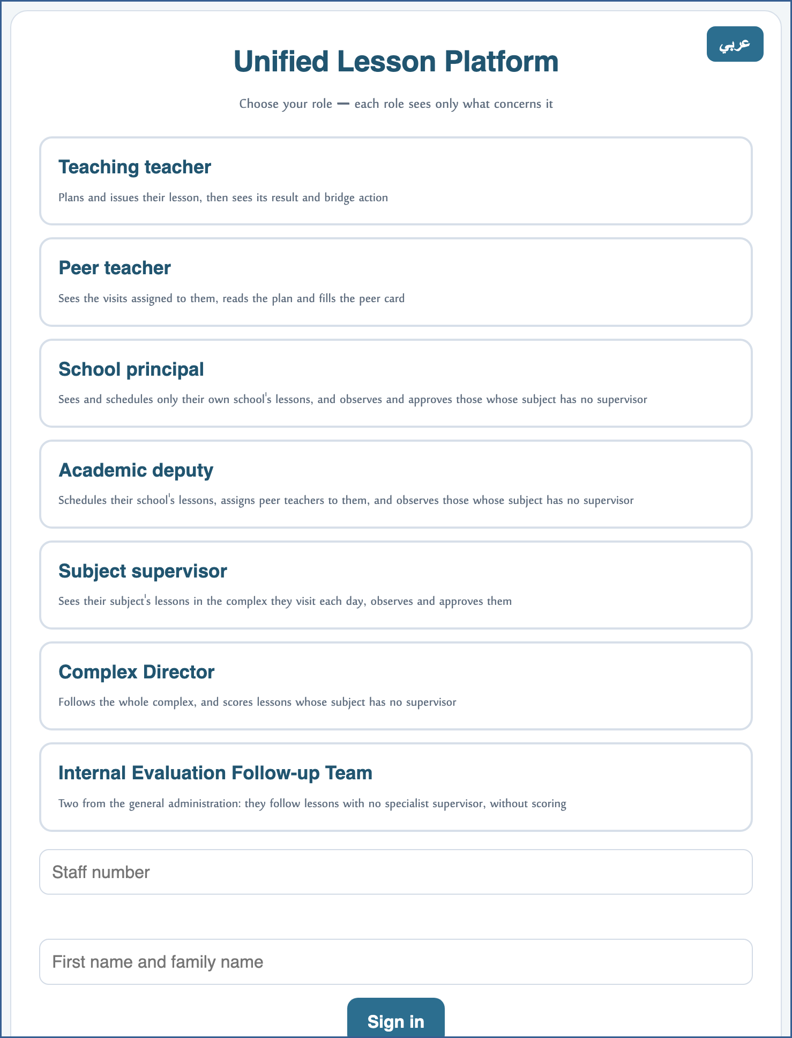
A live screenshot of the platform itself
2 Read your complex's schedule
• The schedule shows every lesson in your complex's schools: week, day, subject and teacher.
• You do not edit a cell in it — scheduling belongs to the teacher and their deputy.
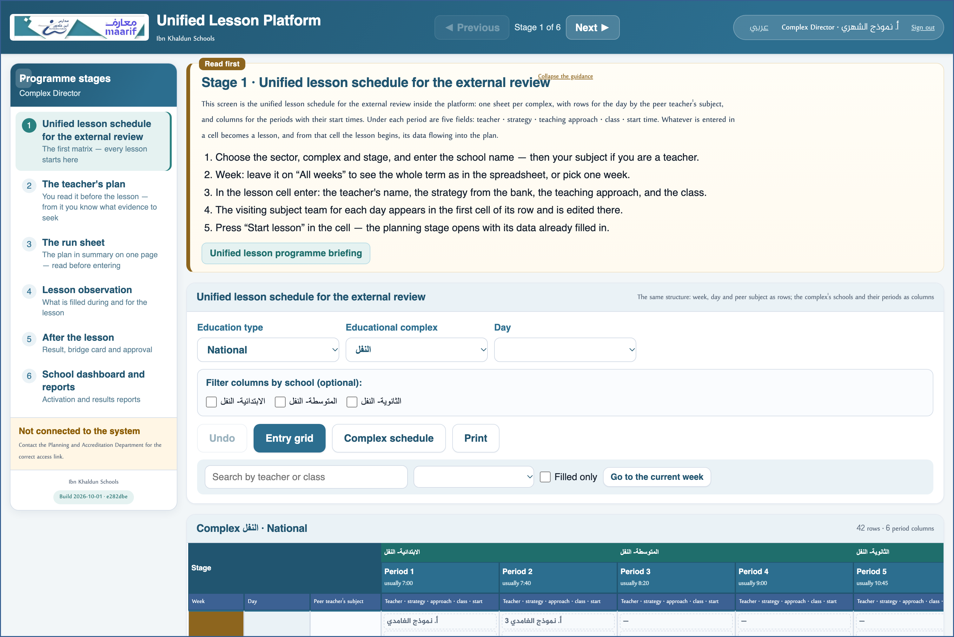
A live screenshot of the platform itself
3 Know what falls to you
• The “Lessons with no subject supervisor” report lists what has no supervisor in your complex.
• These alone are what you observe — together with the academic deputy and the principal.
⛔ What does have a supervisor is not yours to observe: its form does not open for you, and that is correct.

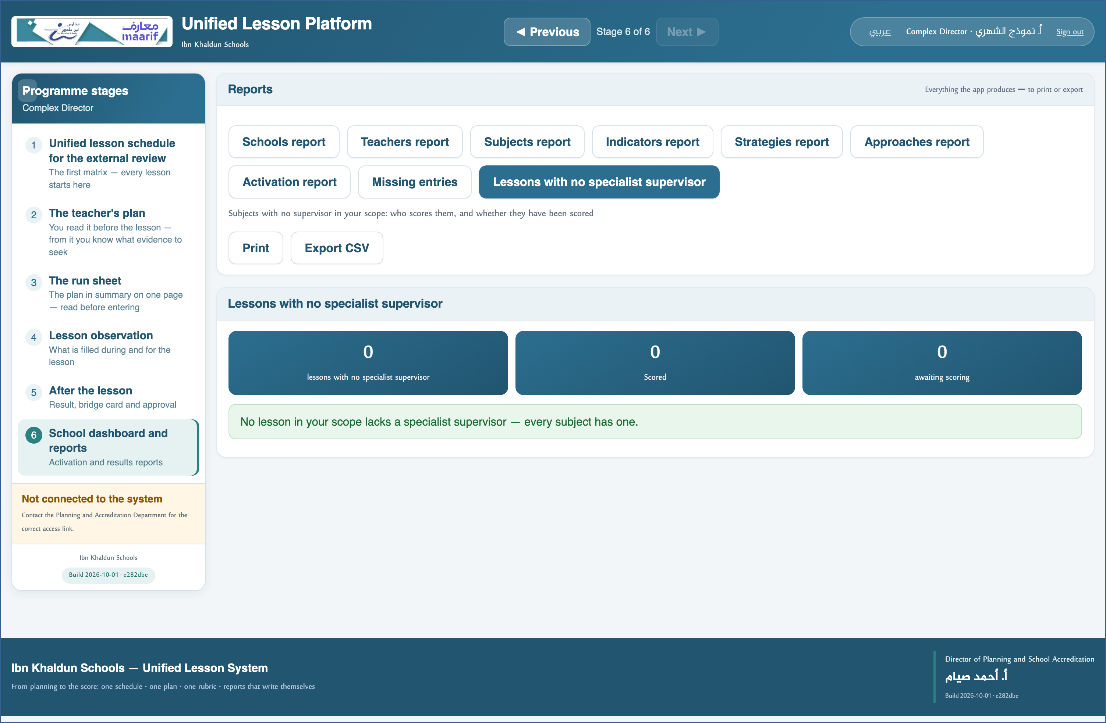
A live screenshot of the platform itself
4 Observe a gap lesson
• Open the lesson from the report; your capacity “Complex manager” is filled in from your role.
• Fill the form and the strategy card, then approve the result.
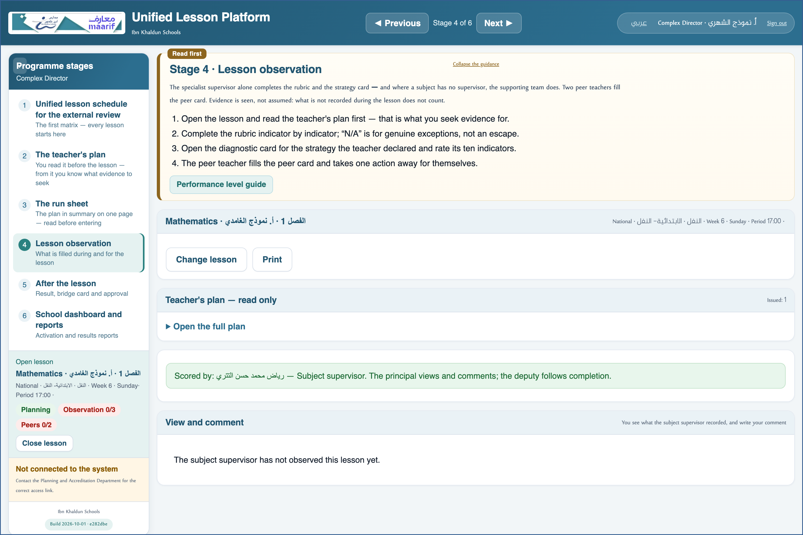
A live screenshot of the platform itself
5 Follow your complex through the reports
• Your complex's reports: teachers and their results · subjects · the weakest indicators · and missing entries.
• All of them are confined to your complex — so what you see concerns you.
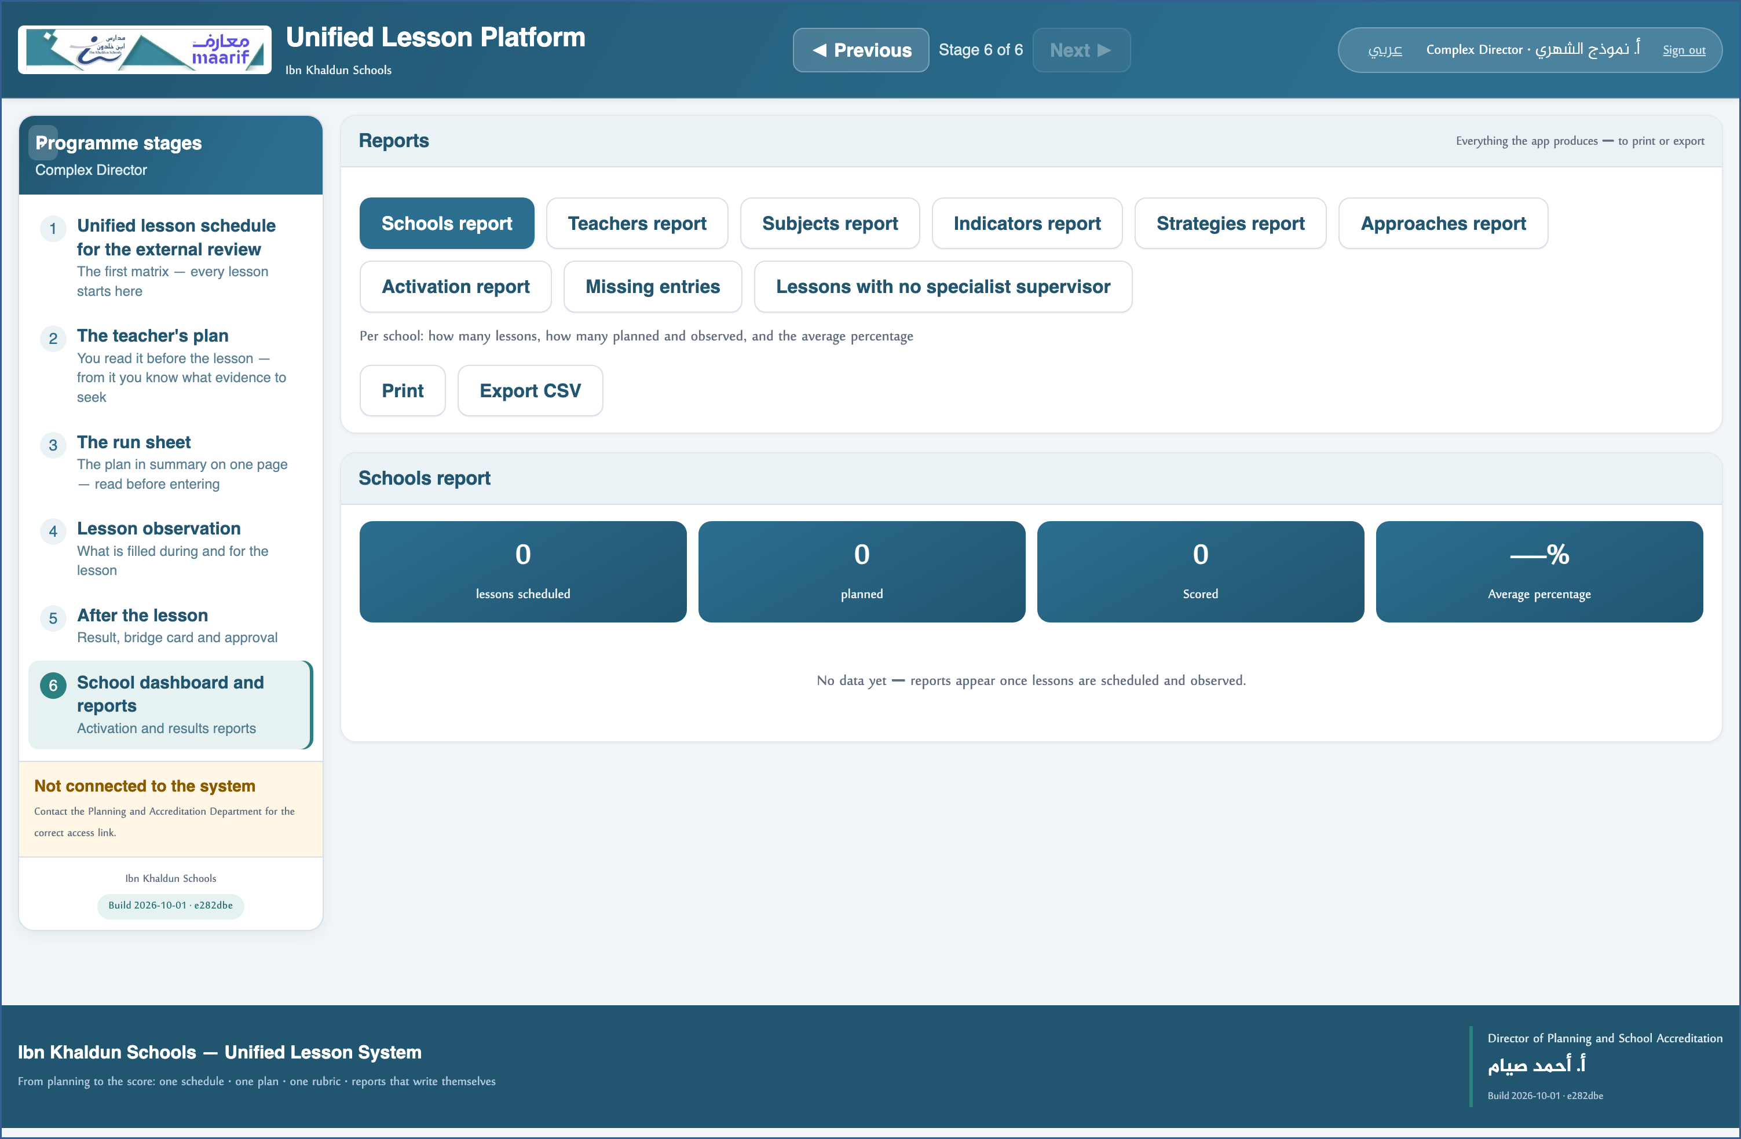
A live screenshot of the platform itself
❖ Where things usually go wrong before you ask — the most common cases
What happens | Why, and what to do
A lesson I can see will not open its form | It has a named subject supervisor, and observing it is theirs. You observe what has none.
I cannot edit a cell in the schedule | Scheduling belongs to the teacher giving the lesson and their deputy; you follow and observe.

❖ Frequently asked
Q: My complex has both boys' and girls' schools?
A: Each sector has its own platform and its own store — you sign in to each separately.
Q: Who approves a result I recorded?
A: You do — whoever observes approves. No one approves a mark whose form they did not fill.
Who to contact
If what concerns you does not appear, or something that is not yours does — contact the Planning and School Accreditation Department.
If the page does not open at all — check the link above and your connection.

https://ahseyam.github.io/unified-lesson/
Planning and School Accreditation Department · Ahmed Seyam

